**Instructions on StufManager Software Installation on Windows 10**

May 2019

Unzip file StufManager_rlsxxxx.zip to extract the executable file setup.exe

Right click on setup.exe, select “Run as administrator” to launch the installation

Follow the process to complete the installation

Unzip file StufManagerSupport.zip to extract the files to StufManagerSupport folder

Copy the folder StufManagerSupport to C:\Windows\SysWOW64

Copy all the files inside of folder StufManagerSupport to C:\Windows\System32

**Attention!** During copying the files, if you see a pop up message “Replace or Skip Files”, such as the one shown below, that means your system already has this file. In this case, please choose Skip this file! Otherwise, your computer may have problem to run your existing programs.

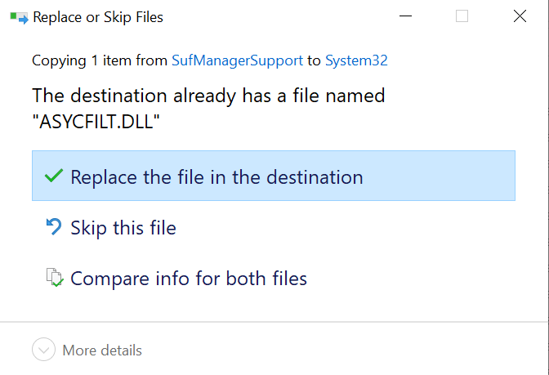

Now, launch the system command window:

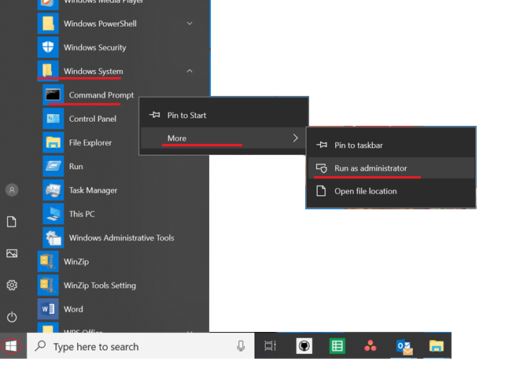

You should see this following window pop up:

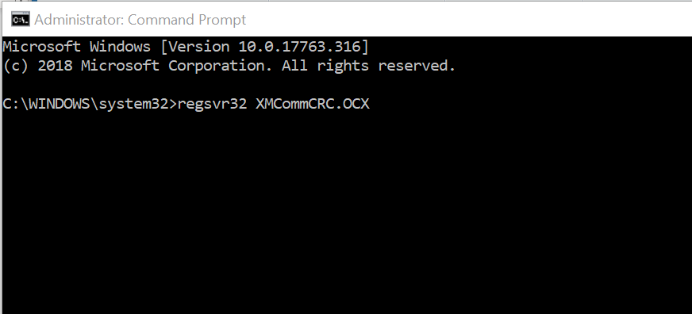

Then, type regsvr32 XMCommCRC.OCX and enter to register component XMCommCRC.OCX. If successful, you should see a notification as following:

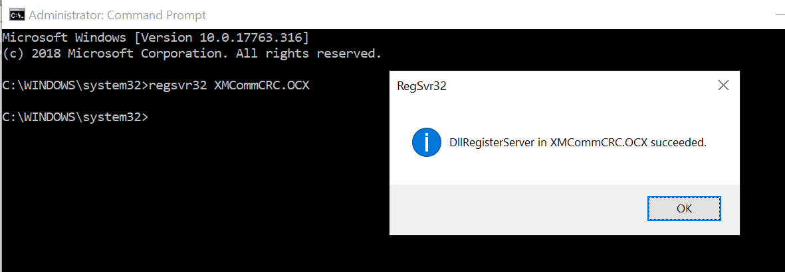

Do the same for components: MSCHRT20.OCX.

Now, launch StufManager program with Run as administrator.

If you see a Run-time error message, saying: Component “xxxxx.xxx” or one of its dependencies not correctly registed: a file is missing or invalid, then, exit the StufManager program, go back to the Command window and register that component.

After this, try again to launch StufManager program with Run as administrator